**Part VIII: Chapter 8: Hypothesis Tests**

**Task 1: Sort the data set according to age and isolate the 15 year olds separated by smoking status. Construct a side-by-side boxplot for FEV values of smokers versus nonsmokers. Insert this boxplot below.**

**What does examination of this boxplot suggest about the difference in mean FEV values between 15 year old smokers and nonsmokers?**

**Task 2: The national average FEV for 15 year old nonsmokers has been reported to be 3.94 liters. Use the sorted values for 15 year old smokers to test the claim that the mean FEV of 15 year old smokers is less than the national average for nonsmokers of 3.94.**

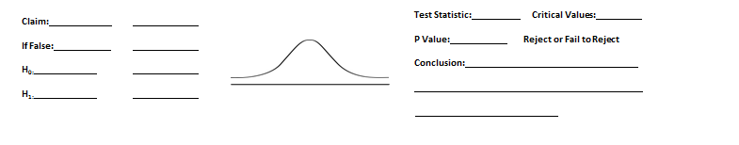

**Task 3:**

* **How does the result of Task 1 compare to the conclusion in Task 2?**
* **Which procedure, a visual examination or a formal hypothesis test, is more valid proof of the belief that smokers have a lower mean FEV than nonsmokers?**

**Task 4: In this data set the proportion of youth smokers was 65 smokers out of 654 participants. Assume that the mayor of Boston has claimed that in his city fewer than 10% of youths smoke. Use this sample and a .05 significance level to test the claim that fewer than 10% of youths in Boston smoke. Write a paragraph describing your testing process and your conclusion.**



* **Explain why the result of your hypothesis test fails to support the claim that the population proportion p is less than 10% even though the sample proportion is less than 10%.**